

A PROJECT REPORT
ON
“Phoenix Unisex Salon & Spa”

SUBMITTED TO SHIVAJI UNIVERSITY, KOLHAPUR
FOR THE PARTIAL FULLFILLMENT OF DEGREE
OF
BACHELOR OF COMPUTER APPLICATIONS
BCA – III
SEM-VI (2025-2026) UNDER FACULTY OF COMMERCE
BY
Dhanashree Suresh Mane( Roll No : 41 ) Shruti Shravan Patil ( Roll No : 66 )
Sandhya Ramesh Dhanawade( Roll No : 13 )

UNDER THE GUIDANCE OF Mr. K. V. KAINGADE (MCM , MCA)
B.C.A. Department
GOPAL KRISHNA GOKHALE COLLEGE,
KOLHAPUR



DEPARTMENT OF COMPUTER APPLICATIONS

Certificate
This is to certify that the project entitled “Phoenix Unisex Salon & Spa” which is being submitted here with for the partial fulfillment of the degree of Bachelor of Computer Applications as laid down by Shivaji University, Kolhapur, is the original work completed in this college by Dhanashree Mane & Shruti Patil & Sandhya Dhanawade under my supervision and guidance and to the best of my knowledge has not submitted to any other University or examining body.

Place: Kolhapur Date:

(H.O.D of B.C.A)

Mr. K.V. Kaingade Examiner
(M.C.M, M.C.A)



DEPARTMENT OF COMPUTER APPLICATIONS

Guide’s Certificate

This is to certify that Dhanashree Mane & Shruti Patil & Sandhya Dhanawade (B.C.A III) has completed her project report on the topic, “ Phoenix Unisex Salon & Spa ” in HTML, CSS and JAVASCRIPT. For the partial fullfillment of the B.C.A. III submitted to the “Shivaji University, Kolhapur ” during the academic year 2025-26 under my guidance.
To the best of my knowledge & belief the matter presented by her is original and has not been copied from any source.

Place: Kolhapur Date:

Mr. K. V. Kaingade (MCM, MCA)
Guide for project Gopal Krishna Gokhale College,
Kolhapur.


DEPARTMENT OF COMPUTER APPLICATIONS

Declaration
I hereby declare that the project entitled “Phoenix Unisex Salon & Spa” has been developed and completed by me is my original work and has not previously been submitted to any University or examining body for the award of any degree.
I have referred the books given in the bibliography during the development of the project and have not copied any of written material or its part thereof. This project is purely on my own and on my merits.

Place: Kolhapur Date:



DEPARTMENT OF COMPUTER APPLICATIONS

Acknowledgement

I would like to thank our Professor Mr. K. V. Kaingade for his valuable guidance and continuous encouragement throughout the development of this project work. I express my sincere thanks to other faculties of this department for their valuable suggestions and support.
I offer sincere thanks to the Co-ordinator Mr. K. V. Kaingade for continuous encouragement in my work.
Last but not least, I would like to express our sincere gratitude to those who have helped me directly and indirectly in my project.

Sr.No. | Title | Page No.
1. | Introduction  - Existing System  - Need And Scope of System | 1 to 8
2. | Proposed System  - Objectives  - Requirement Gathering  - Requirement Analysis | 9 to 16
3. | System Analysis  - DFD  - ERD  System Requirements  - Hardware  - Software | 17 to 25
4. | System Design  - Database Design  - Output Design | 26 to 38
5. | User Manual | 39 to 40
6. | Source Code | 41 to 44
7. | Outputs  Reports | 45 to 48
8. | Conclusion And Suggestions  - Conclusion And Suggestions  - Future Enhancement  - References | 49 to 54

INTRODUCTION

Introduction
The Salon Management System is a web-based application developed to manage and automate the daily operations of a salon efficiently. This project was designed based on the real-world requirements of our own salon, where managing appointments, customer records, and services manually became increasingly challenging as the number of customers grew. The system aims to provide a simple, reliable, and organized platform to handle salon activities in a digital environment.
In traditional salon management, tasks such as booking appointments, maintaining customer details, and tracking services are often performed manually using notebooks or registers. These manual processes can lead to errors, delays, and difficulty in managing records. Recognizing these issues, the Salon Management System was developed to replace manual methods with an automated system that improves accuracy, saves time, and enhances overall efficiency.
The system provides features such as appointment scheduling, customer management, service management, and an administrative dashboard for monitoring salon operations. All information is stored securely in a database, allowing staff to quickly access and update records whenever needed. This helps salon owners manage their business more effectively and provide better service to customers.
Furthermore, the Salon Management System supports better decision-making by maintaining organized records of customers and services. It also reduces paperwork, minimizes human errors, and improves productivity. The system can be expanded in the future to include additional features such as online booking, payment integration, notifications, and reporting tools.
Overall, the project demonstrates how modern web technologies can be used to solve real-life business problems and improve the efficiency of salon management.

EXISTING SYSTEM

Existing System

The existing system in our salon was based on manual methods for managing daily operations. Activities such as appointment scheduling, customer record maintenance, and service tracking were handled using notebooks and paper registers. Staff members recorded customer details, service information, and appointment timings manually, which required significant time and effort to maintain.
As the number of customers increased, managing records manually became more difficult and less efficient. Searching for customer details or previous appointment history often took a long time, especially during busy working hours. This manual approach also increased the chances of human errors such as incorrect entries, missed appointments, and double bookings.
In addition, the manual system did not provide proper data security or backup. Physical records could be lost, damaged, or misplaced due to accidents or improper handling.
Generating reports, calculating daily income, and analyzing business performance required manual calculations, which were time-consuming and sometimes inaccurate. Therefore, the limitations of the existing manual system highlighted the need for a computerized solution that could automate salon operations, improve efficiency, and provide reliable data management.

Limitations of the Existing System
- Manual record keeping using notebooks and registers
- Time-consuming appointment management
- High chances of human errors
- Difficulty in searching customer records
- No proper data backup or security
- Manual calculation of reports and revenue
- Increased workload for staff
- Inefficient management of daily salon operations

NEED OF SYSTEM

Need of System

The need for the Salon Management System arose due to the increasing challenges faced in managing salon operations manually. In our salon, daily activities such as appointment scheduling, customer record maintenance, and service tracking were handled using traditional methods like notebooks and manual registers. These methods were time- consuming, difficult to manage, and prone to human errors.
As the number of customers grew, maintaining accurate records and organizing appointments became more complex. Staff members had to spend considerable time searching for customer details, updating information, and coordinating schedules. This reduced overall productivity and sometimes caused delays in providing services to customers.
There was also a need for a reliable system to store data securely and access it quickly whenever required. Manual record-keeping did not provide proper backup facilities, and important information could be lost or damaged. Therefore, a computerized system was required to improve efficiency, reduce manual workload, and ensure data accuracy.
The Salon Management System was developed to address these needs by providing an automated and user-friendly platform for managing salon activities. It helps streamline operations, improve customer service, and support better decision-making through organized and easily accessible records.

Key Reasons for the Need of the System
- To reduce manual paperwork and record keeping
- To improve appointment scheduling efficiency
- To store customer data securely
- To minimize human errors
- To save time and increase staff productivity
- To provide quick and easy access to information
- To improve overall salon management and customer satisfaction

SCOPE OF SYSTEM

Scope of System
The Salon Management System is designed to simplify and automate the daily operations of a salon through a web-based platform. The system helps manage customer records, appointments, and services efficiently while reducing manual workload and errors. It provides a centralized system where administrators can monitor salon activities, store data securely, and access information quickly whenever required.
This system is developed based on real-life requirements observed in our own salon, where manual record-keeping created difficulties in managing appointments and customer information. By digitizing these processes, the system improves efficiency, accuracy, and customer satisfaction. The system also allows future enhancements to support advanced features and better business management.
Key Areas of Scope
- User Management
Secure login and authentication for administrators.
- Ensures authorized access to system features.
- Customer Management
- Stores and manages customer details and service history.
- Allows adding, updating, and deleting customer records.
- Appointment Management
- Schedules and tracks customer appointments.
- Helps avoid booking conflicts and missed appointments.
- Service Management
- Maintains details of salon services, prices, and duration.
- Allows administrators to manage service information easily.

- Reporting and Dashboard
- Displays booking and customer information.
- Helps monitor salon performance and daily operations.

- Security and Data Management
- Protects data through secure login and database storage.
- Ensures data accuracy and reliability.

PROPOSED SYSTEM

Proposed System
The Proposed System is a web-based Salon Management System developed to overcome the limitations of the existing manual system. It provides an automated and efficient solution for managing daily salon operations such as customer records, appointment scheduling, and service management. The system uses modern web technologies to store and process data in a structured database, ensuring accuracy, reliability, and easy access to information.
In the proposed system, all salon activities are managed digitally through a user-friendly interface. Administrators can quickly add new customers, schedule appointments, update service details, and monitor business operations from a centralized dashboard. The system reduces manual work, minimizes errors, and improves the overall productivity of salon staff.
The proposed system also ensures better data security and organization by maintaining records in a computerized database. It supports faster decision-making by providing real-time information about bookings, customers, and services. Overall, the system improves efficiency, enhances customer service, and provides a reliable platform for managing salon operations effectively.
Key Features of the Proposed System
- Automated Appointment Scheduling
- Allows quick booking, updating, and cancellation of appointments.
- Reduces scheduling conflicts and missed bookings
- Customer Record Management
- Maintains accurate customer details and service history.
- Enables easy search and retrieval of customer information.
- Service Management
- Stores details of services, prices, and duration.
- Allows administrators to update service information easily.
- Dashboard and Monitoring
- Provides a centralized dashboard to track salon activities.
- Displays important information such as total bookings and customers.

OBJECTIVES

Objectives

The main objective of the Salon Management System is to develop an efficient and user-friendly application that automates the daily operations of a salon. The system aims to reduce manual work, improve accuracy in managing customer records, and provide a reliable platform for scheduling appointments and managing services. It helps salon staff perform their tasks quickly and efficiently while ensuring better organization of salon activities.
Another objective of the system is to store and manage salon data securely in a structured database, allowing easy access and retrieval of information whenever required. The system also aims to improve customer satisfaction by providing faster service and reducing waiting time. Overall, the project focuses on improving operational efficiency, reducing errors, and supporting better decision-making in salon management.

Objectives of the System – Key Points
- To automate salon management operations
- To reduce manual paperwork and workload
- To manage customer records efficiently
- To schedule and track appointments easily
- To maintain details of salon services and pricing
- To improve data accuracy and reduce human errors
- To store data securely in a database
- To improve overall efficiency and productivity
- To enhance customer satisfaction

REQUIREMENT GATHERING

Requirement Gathering
Requirement Gathering is the process of collecting information about the needs and expectations of users for developing the Salon Management System. In this project, requirements were gathered by observing the daily operations of our own salon, discussing challenges with staff members, and identifying the problems faced while managing appointments, customer records, and services manually.
The information collected helped in understanding the limitations of the existing system and determining the features needed in the new system. The gathered requirements focused on improving efficiency, reducing manual work, and ensuring accurate data management. These requirements were then used as the foundation for designing and developing the Salon Management System.
Sources of Requirement Gathering
- Observation of daily salon operations
- Discussion with salon staff and owner
- Review of manual record-keeping methods
- Identification of common problems in appointment management
- Analysis of customer service requirements
Types of Requirements Collected
- FunctionalRequirements
These describe what the system should do.
- Add, update, and delete customer records
- Schedule and manage appointments
- Manage salon services and pricing
- Provide admin login and dashboard
- Store and retrieve data from the database

- Non-FunctionalRequirements
These describe how the system should perform.
- Easy-to-use interface
- Fast system response time
- Secure login and data protection
- Reliable data storage
- System availability during working hours

REQUIREMENT ANALYSIS

Requirement Analysis
Requirement Analysis is the process of examining and understanding the requirements collected during the requirement gathering phase. In the Salon Management System, the gathered requirements were carefully analyzed to determine the system features, user needs, and technical specifications necessary for developing an efficient and reliable application.
During this phase, the problems in the existing manual system were studied, such as difficulty in managing appointments, maintaining customer records, and generating reports. Based on this analysis, the system was designed to automate these tasks and provide a simple and user-friendly interface for salon staff and administrators.
The requirement analysis also helped identify the functional and non-functional requirements of the system, ensuring that the application meets user expectations, performs efficiently, and maintains data security. This step played an important role in defining the structure, workflow, and overall functionality of the Salon Management System.

Key Points of Requirement Analysis
- Functional-Requirements
These define the main operations the system must perform.
- User login and authentication
- Customer record management
- Appointment scheduling and tracking
- Service management
- Dashboard and reporting features
- Data storage and retrieval
- Non-Functional-Requirements
These define the performance and quality of the system.
- User-friendly interface
- Fast system performance
- Secure data handling
- Reliable database storage
- System availability during working hours

DATAFLOW DIAGRAM

Data Flow Diagram(DFD)
Level 0 and 1 DFD
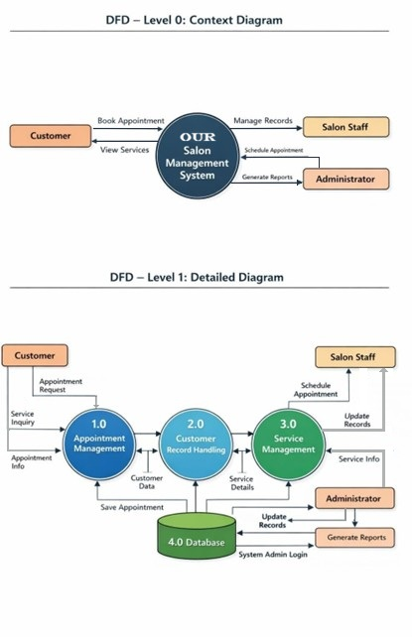

Level 2DFD

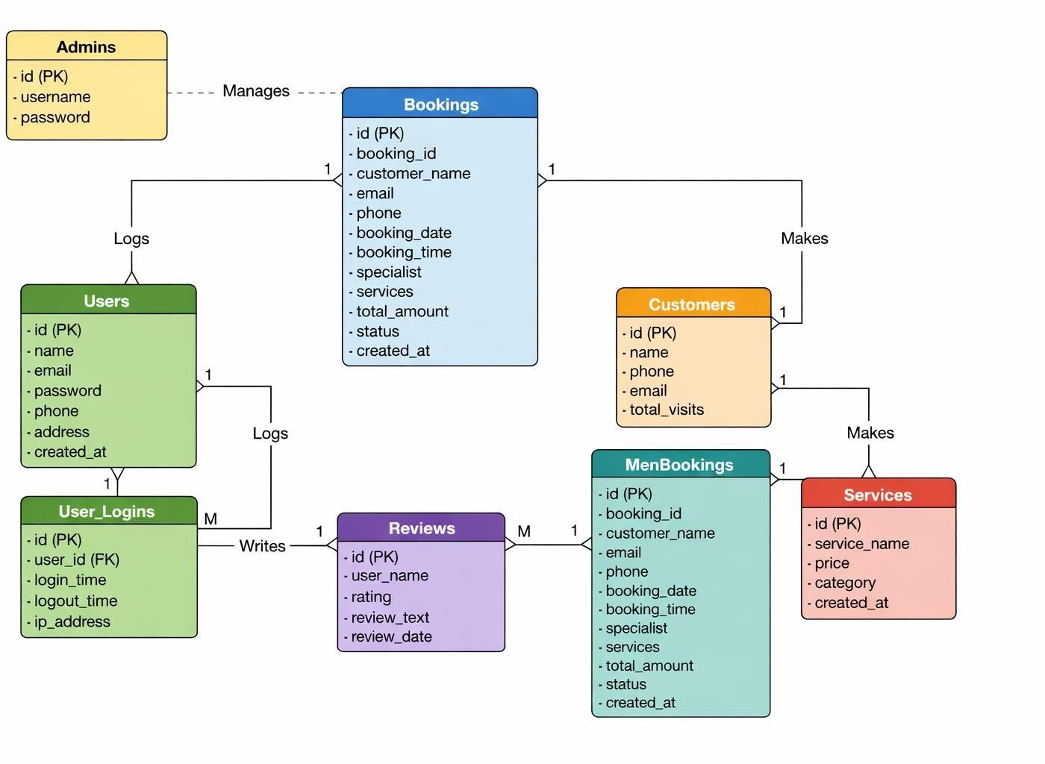

ENTITY

RELATIONSHIPDIAGRAM

Entity Relationship Diagram(ERD)

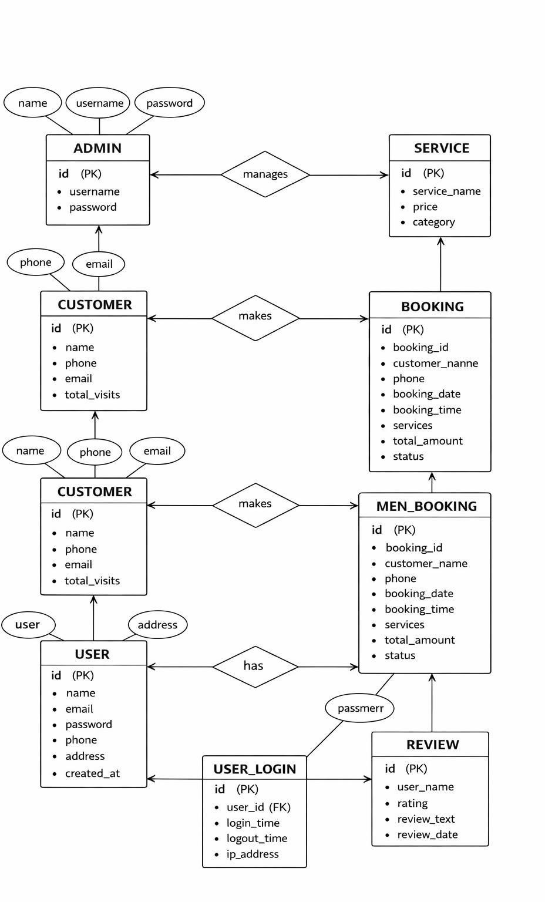

HARDWARE REQUIREMENT

System Requirements

The System Requirements define the minimum hardware and software components needed to develop and run the Salon Management System successfully. These requirements ensure that the system operates smoothly, provides reliable performance, and supports efficient data processing. The system is designed to run on a standard computer with commonly available software tools, making it suitable for small and medium-sized salon businesses.
The requirements are divided into two main categories: Hardware Requirements and Software Requirements.

Hardware Requirements
The hardware requirements specify the physical components needed to run the system effectively.
- Processor: Intel Core i3 or higher
- RAM: Minimum 4 GB
- Hard Disk: Minimum 20 GB free space
- Monitor: Standard display monitor
- Keyboard and Mouse: Required for user input
- Printer: Optional (for printing reports and receipts)
- Internet Connection: Optional (for updates or online features)

Software Requirements
The software requirements specify the programs and tools required to develop and operate the system.
- Operating System: Windows 10 or later
- Programming Language: PHP
- Frontend Technologies: HTML, CSS, JavaScript, Bootstrap
- Database: MySQL
- Web Server: XAMPP / Apache Server
- Browser: Google Chrome, Microsoft Edge, or any modern web browser
- Version Control (Optional): Git and GitHub

SOFTWARE REQUIREMENT

Software Requirements

Software Requirements
The software requirements specify the programs and tools required to develop and operate the system.
- Operating System: Windows 10 or later
- Programming Language: PHP
- Frontend Technologies: HTML, CSS, JavaScript, Bootstrap
- Database: MySQL
- Web Server: XAMPP / Apache Server
- Browser: Google Chrome, Microsoft Edge, or any modern web browser
- Version Control (Optional): Git and GitHub

DATABASE DESIGN

Database Design

TABLES
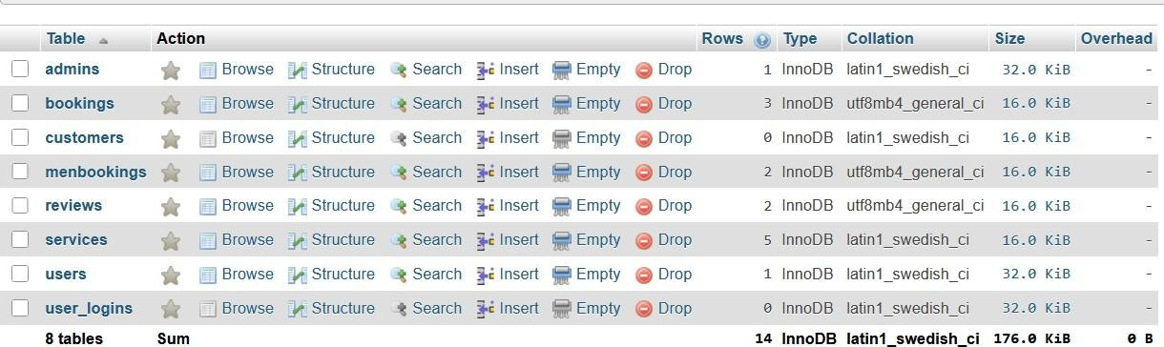

ADMIN
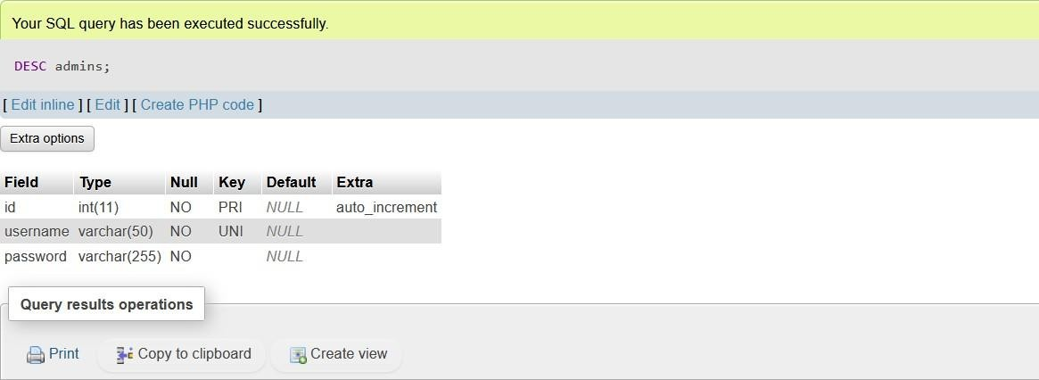

BOOKINGS
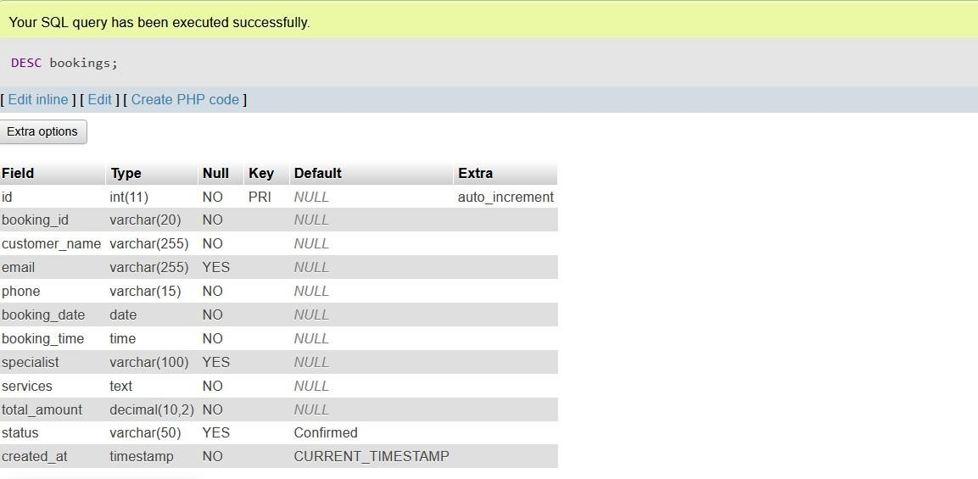

CUSTOMERS
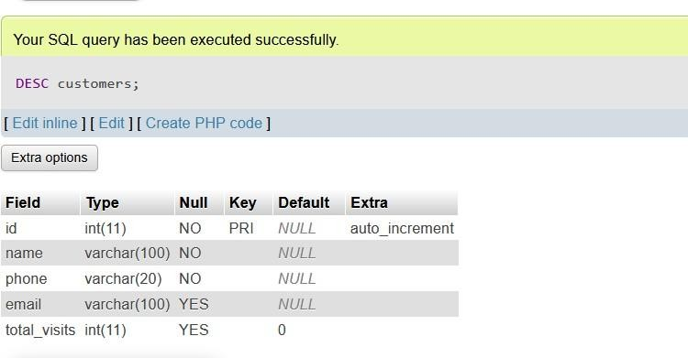

MENBOOKINGS

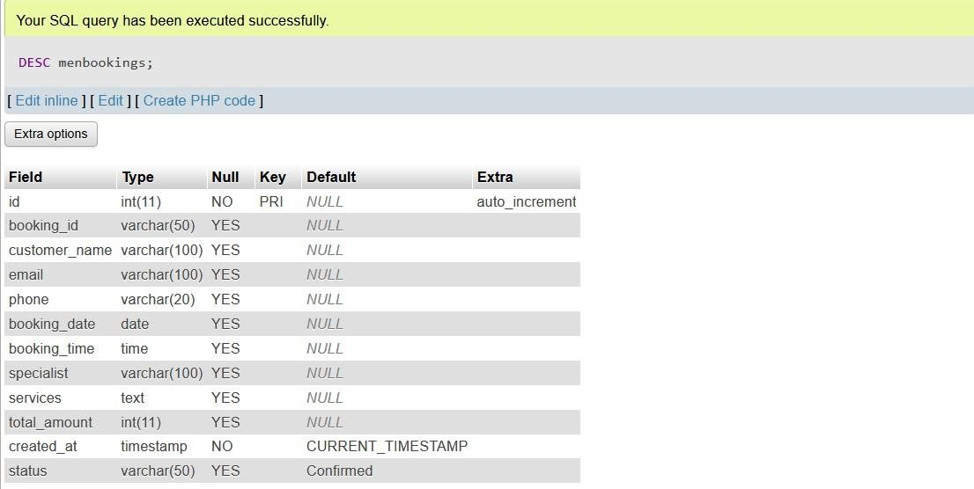

REVIEWS

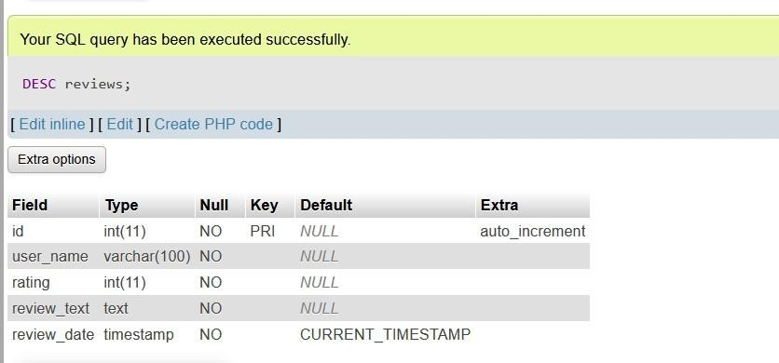

SERVICES

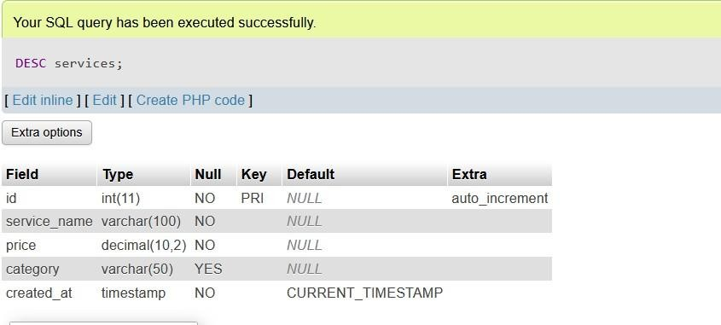

USERS

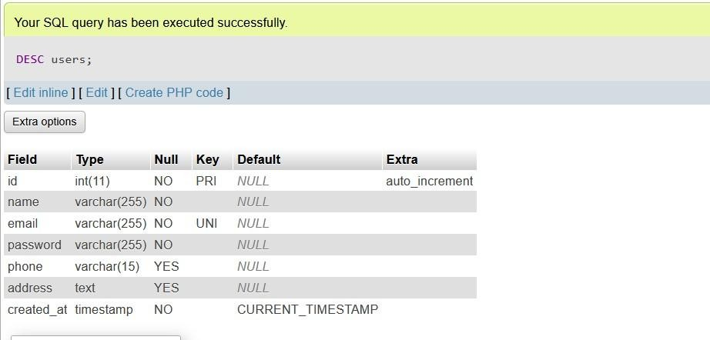

USERS_LOGIN
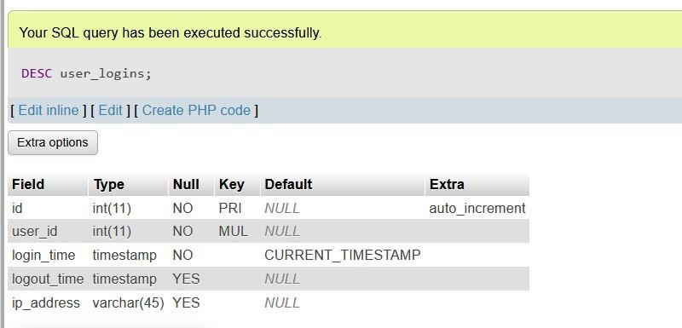

OUTPUT DESIGN

Output Design
Home page Design:
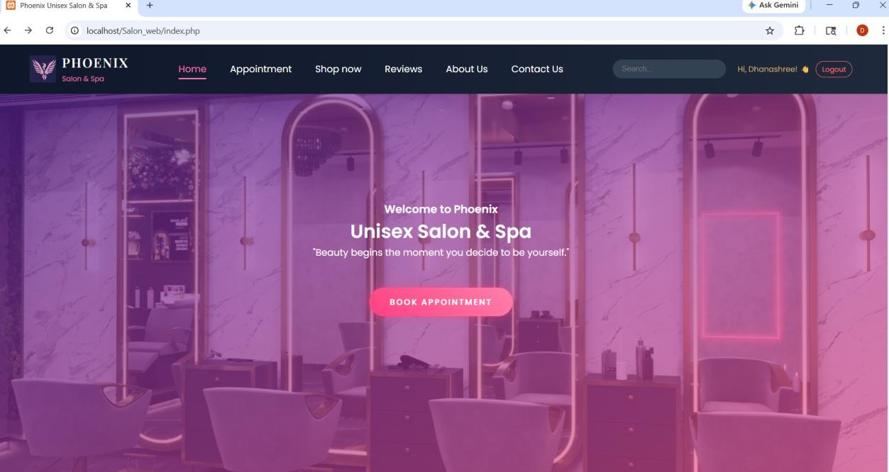

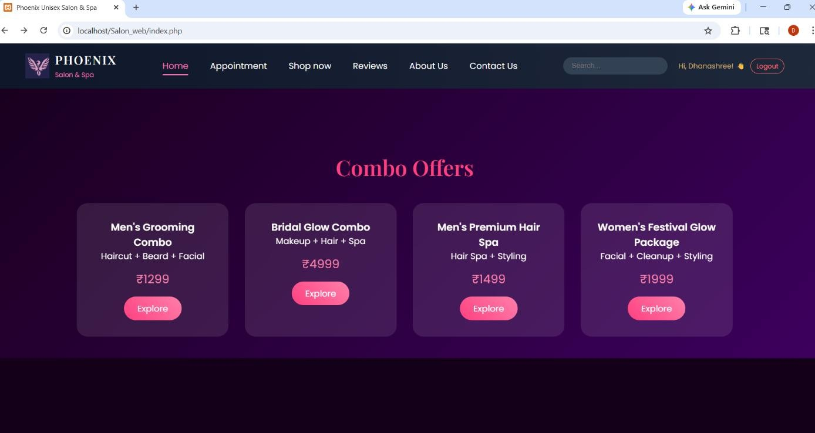

USER_Login Design :
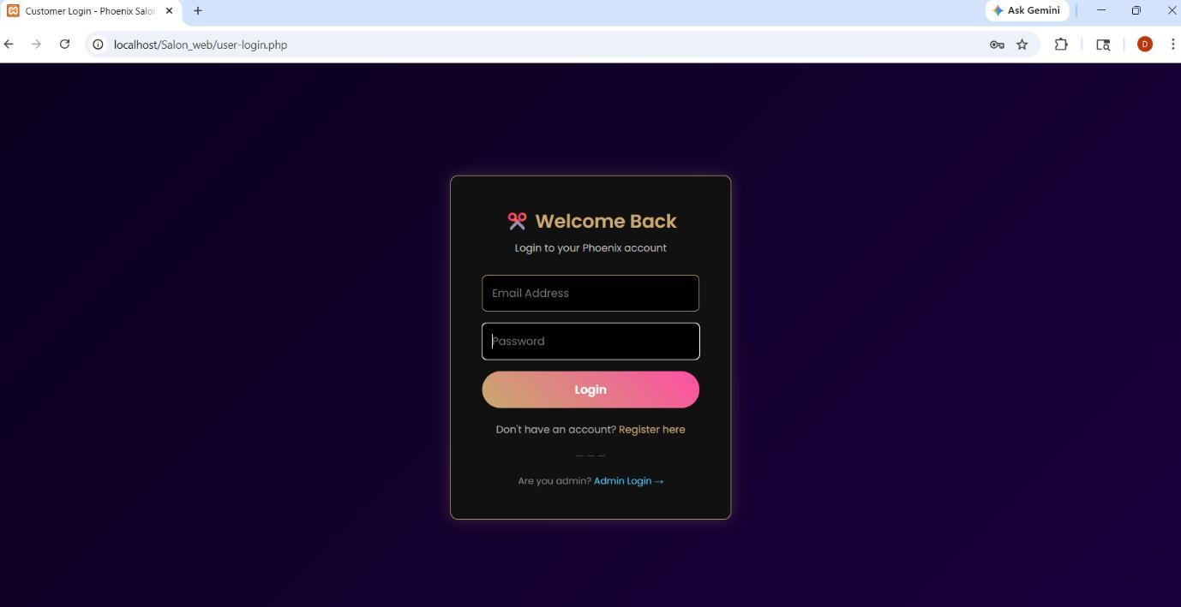

ADMIN_Login Design :

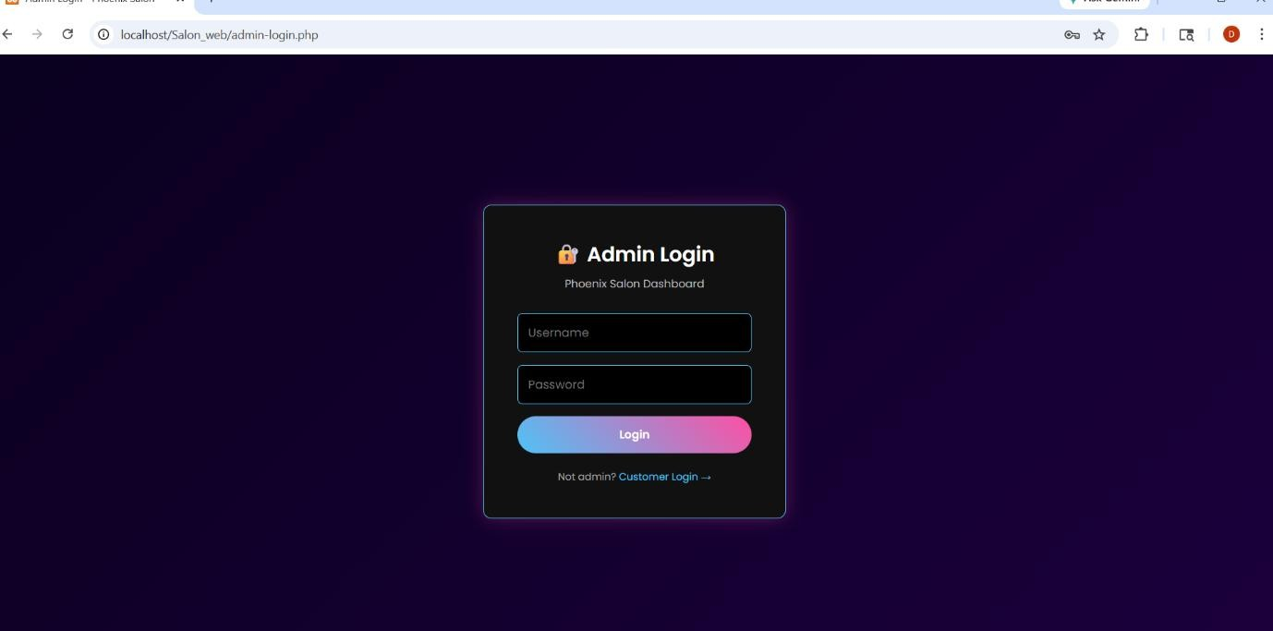

Sign up page:
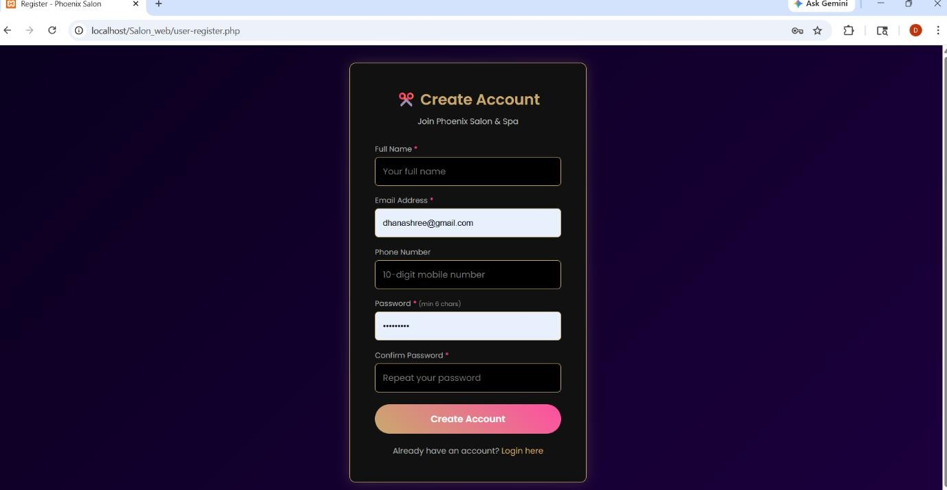

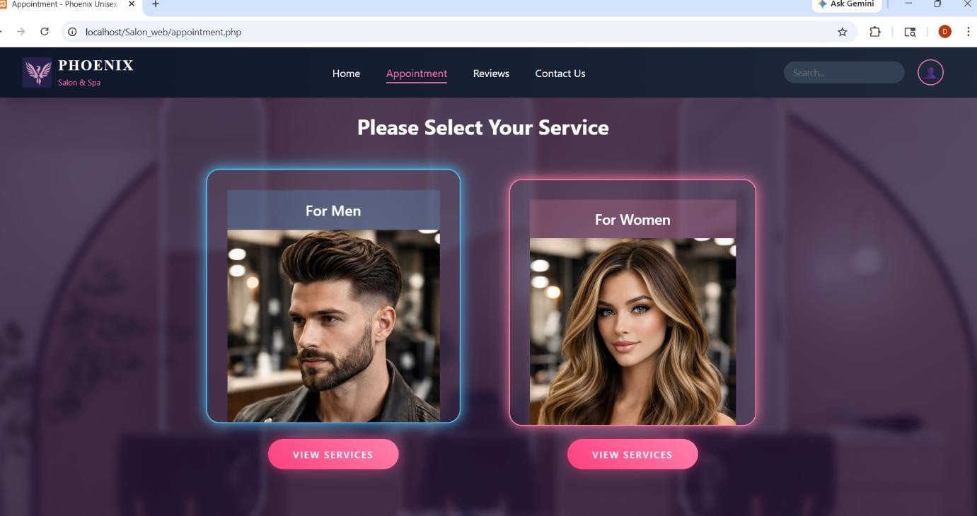

Women’s and Men's Premium Services Designs:

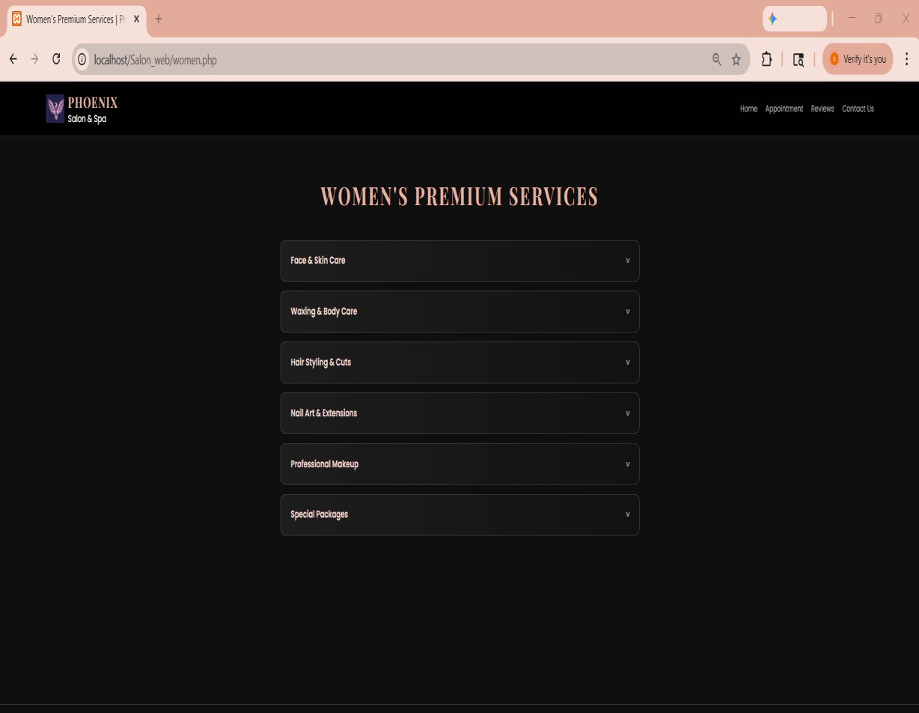

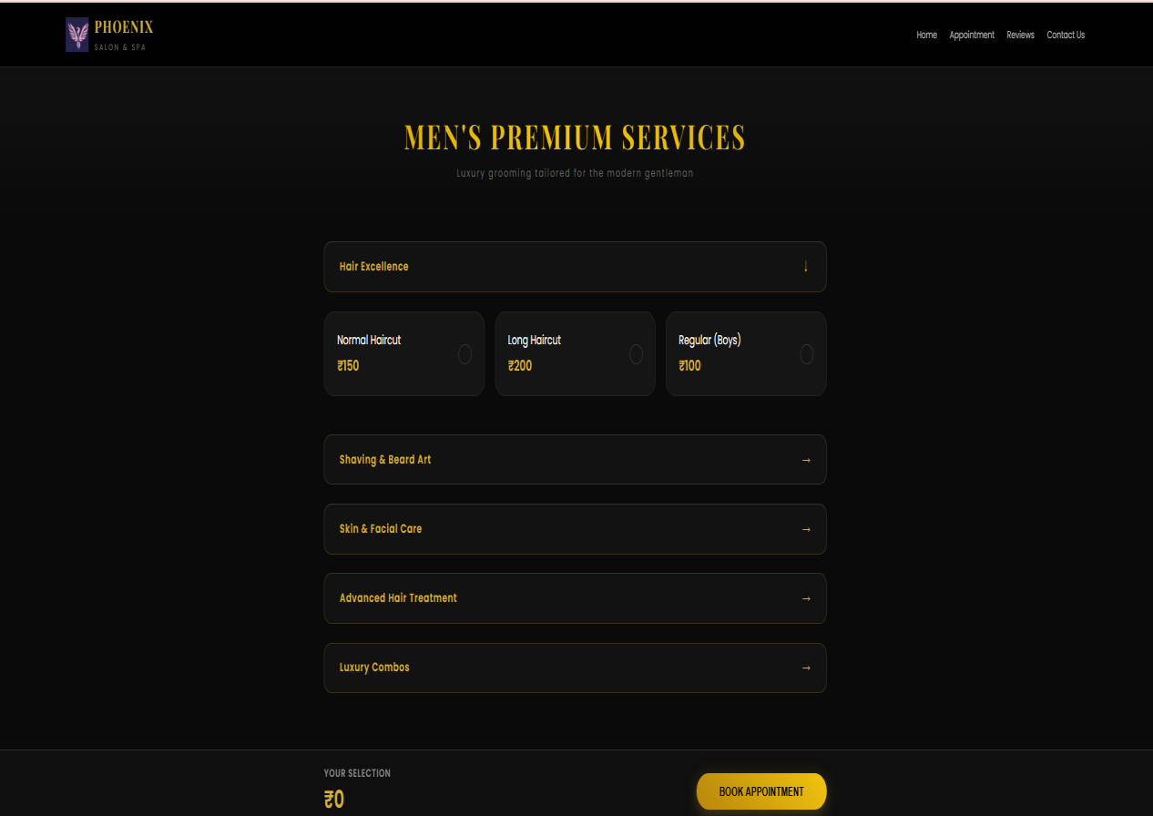

Reservations Designs:
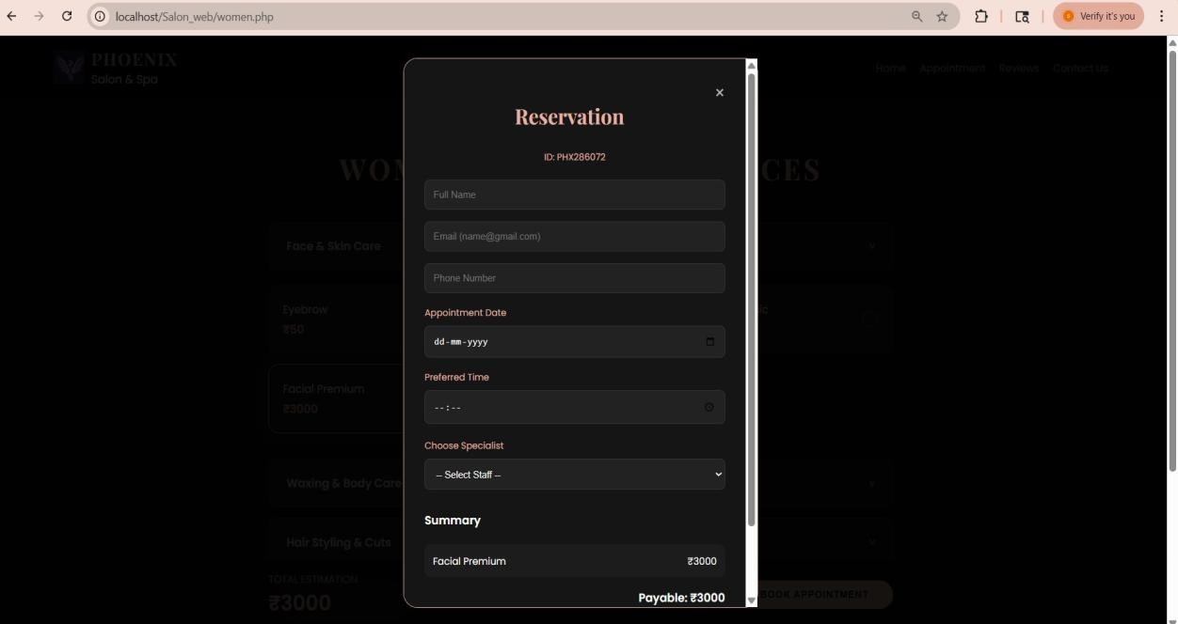

Reviews Designs:

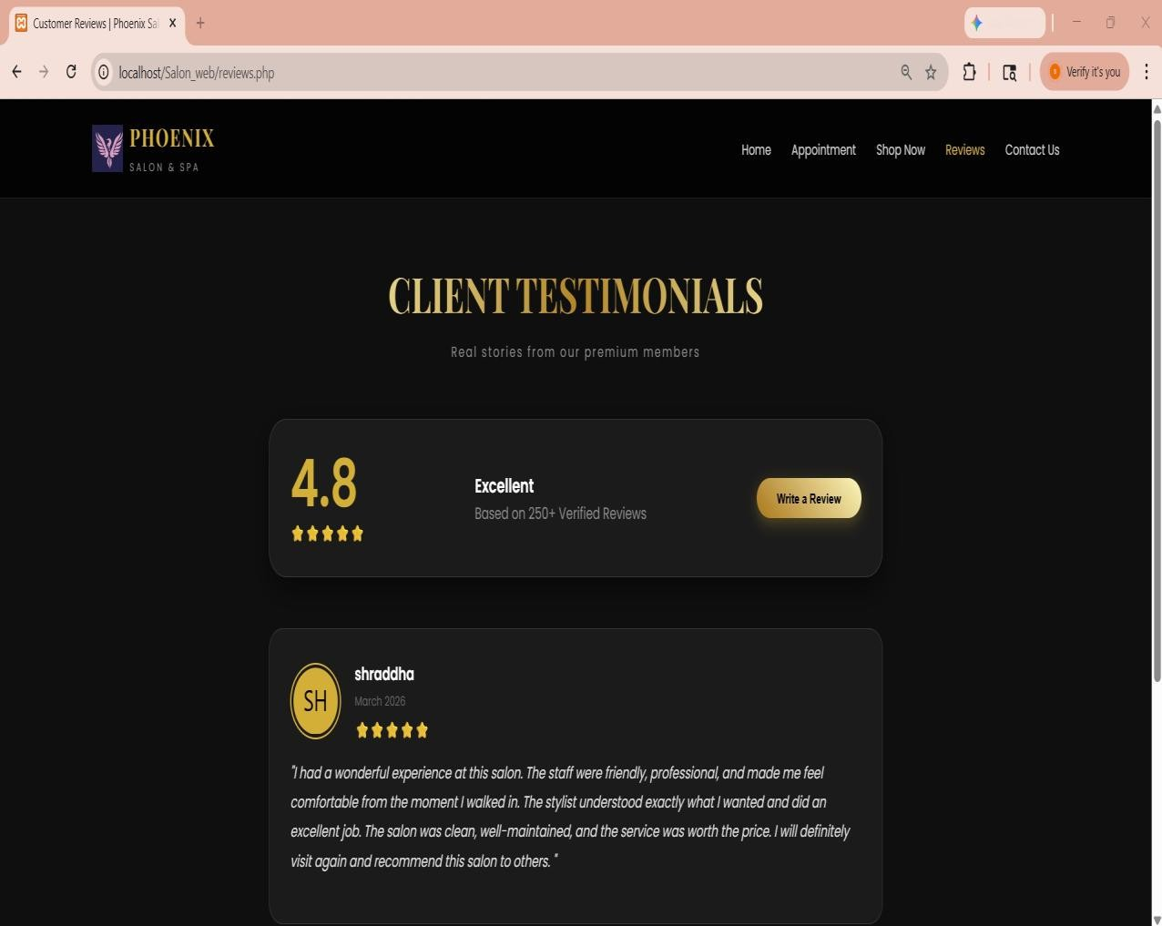

Contact US Designs:
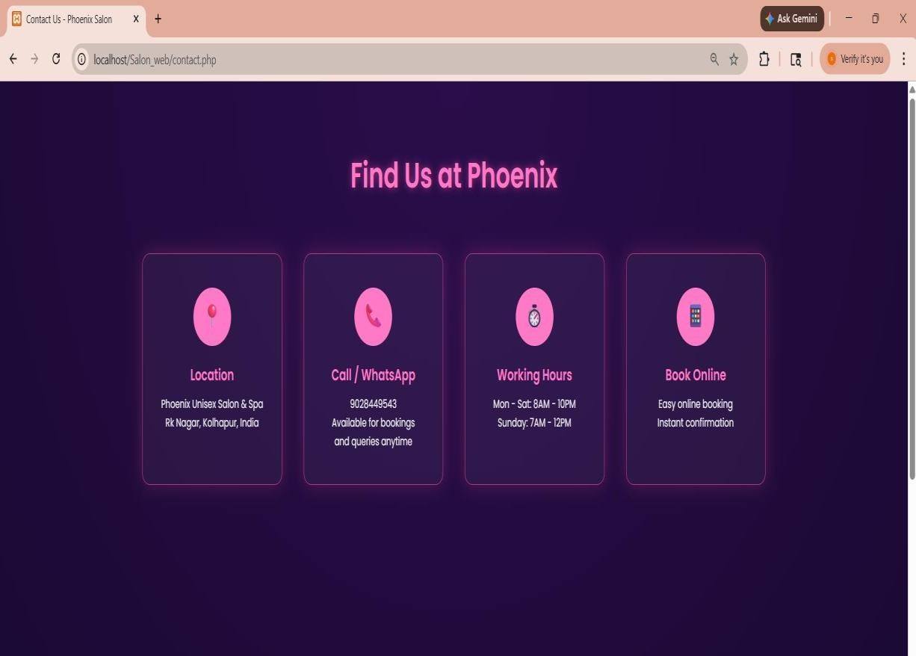

Location:
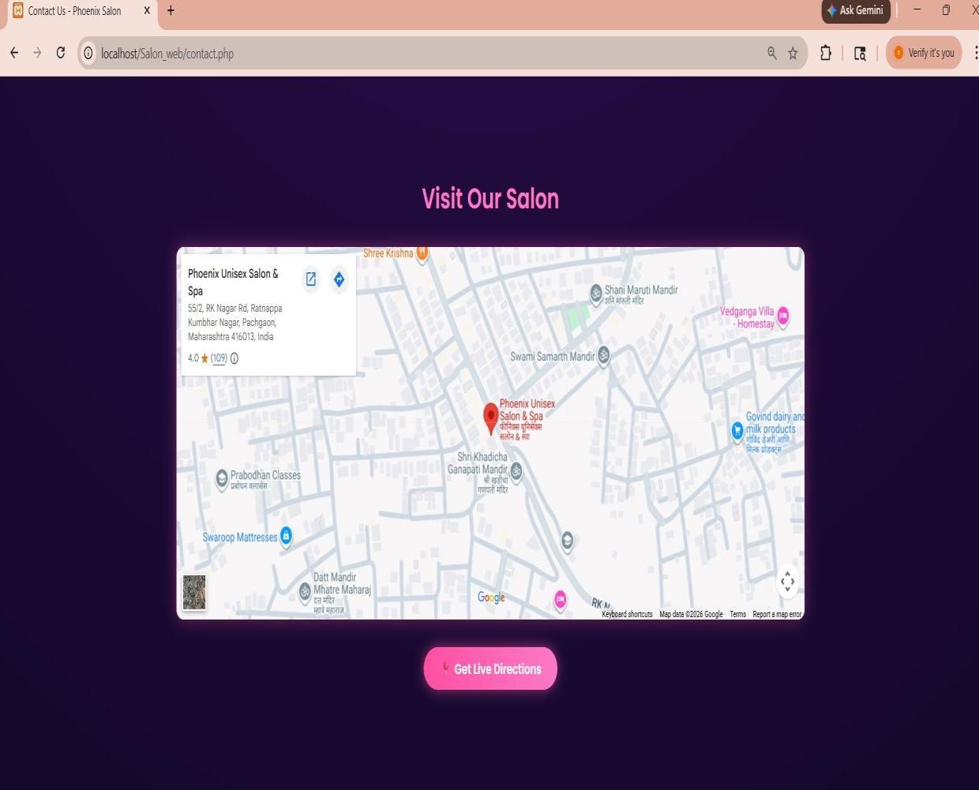

USER MANUAL

USER MANUAL

- System Login Steps to log in:
  - Open the web browser and enter the system URL (localhost or server URL).
  - Enter your username and password.
  - Click the Login button.
  - If credentials are correct, the user is redirected to the Admin Dashboard.
  - For invalid credentials, an error message is displayed.

- Dashboard Overview The Dashboard provides a summary of salon operations:
- Total Bookings
- Total Customers
- Total Revenue
- Pending Appointments

- Customer Management Adding a New Customer:
  - Navigate to the Customer Management module.
  - Click Add Customer.
  - Fill in customer details: Name, Phone, Email, Address.
  - Click Save to store the record.

- Appointment Management Scheduling a New Appointment:
  - Go to the Appointments module.
  - Click Add Appointment.
  - Select customer, service, date, and time.
  - Click Save to confirm the booking.

  - Service Management Adding a New Service:
    - Navigate to the Service Management module.
    - Click Add Service.
    - Enter service name, price, and duration.
    - Click Save to store the service.

  - Logout
- Click the Logout button on the dashboard.
- The user will be redirected to the login page.
- Always log out after use to ensure data security.

.

SOURCE CODE

Source code
admin-login.php
<?php session_start();
if (isset($_SESSION['user_logged_in']) && $_SESSION['user_logged_in'] === true) { header('Location: index.php');
exit();
}
if (isset($_SESSION['admin_logged_in']) && $_SESSION['admin_logged_in'] === true) { header('Location: admin.php');
exit();
}
include('db_config.php');
$error = '';
If ($_SERVER['REQUEST_METHOD'] === 'POST') {
$username = trim($_POST['username']);
$password = trim($_POST['password']);
$adminUser = 'phoenix';
$adminPass = 'admin123';
If ($username === $adminUser && $password === $adminPass) {
$_SESSION['admin_logged_in'] = true; header('Location: admin.php'); exit();
} else {
$error = 'Invalid Username or Password';
}
}
?>
<!DOCTYPE html>
<html lang="en">
<head>

<meta charset="UTF-8">
<title>Admin Login - Phoenix Salon</title>
<meta name="viewport" content="width=device-width, initial-scale=1.0">
<link href="https://fonts.googleapis.com/css2?family=Poppins:wght@300;400;600&display=swap " rel="stylesheet">
<link rel="stylesheet" href="admin-login.css">
<style>
.login-wrapper { display: flex;
justify-content: center; align-items: center; height: 100vh; flex-direction: column;
}
.admin-box { background: #111; padding: 40px; width: 360px; border-radius: 10px; border: 1px solid #4fc3f7; text-align: center;
box-shadow: 0 0 20px rgba(255, 79, 163, 0.3);
}
.admin-box h2 { margin-bottom: 6px; color: #fff;
}
.admin-box .subtitle { color: #bbb; font-size: 13px; margin-bottom: 25px;
}
user-link { display: block;
margin-top: 18px; color: #aaa; font-size: 12px;
text-decoration: none;
}
.user-link a { color: #4fc3f7;
text-decoration: none;
}
.user-link a:hover {
text-decoration: underline;
}
.error-text { color: #ff4fa3;

margin-top: 12px; font-size: 13px;
}
</style>
</head>
<body class="admin-body">
<div class="login-wrapper">
<div class="admin-box">
<h2>çt'P Admin Login</h2>
<p class="subtitle">Phoenix Salon Dashboard</p>
<form id="loginForm" method="POST" action="admin-login.php"> required>
<div class="input-group">
< input type="text" name="username" placeholder="Username" autocomplete="username"
</div>
<div class="input-group">
<input type="password" name="password" placeholder="Password" autocomplete="current-password" required>
</div>
<button type="submit" class="admin-btn">Login</button>
<?php if ($error): ?>
<p class="error-text"><?= htmlspecialchars($error) ?></p>
<?php endif; ?>
</form>
<span class="user-link">Not admin? <a href="user-login.php">Customer Login →</a></span>
</div>
</div>
</body>
</html>

ADMIN REPORTS

Admin dashboard:
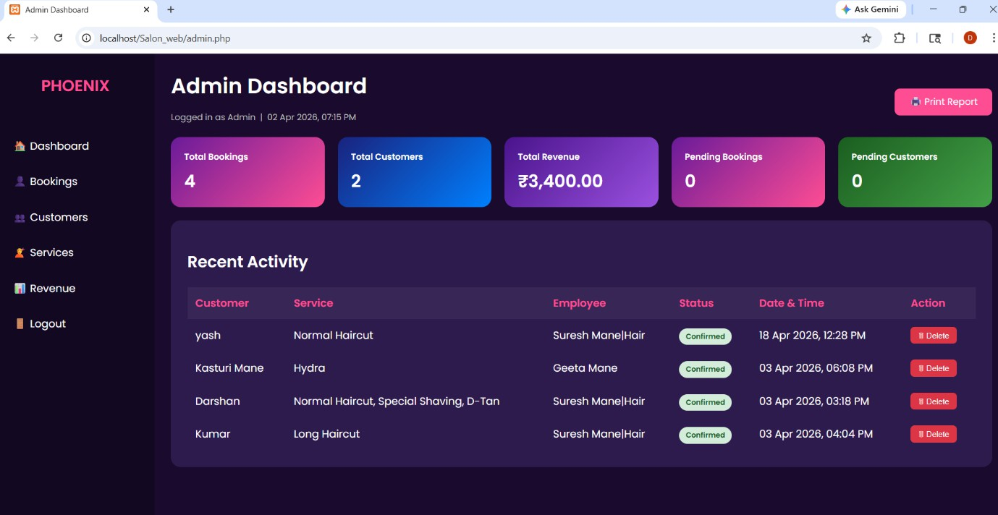

Bookings:
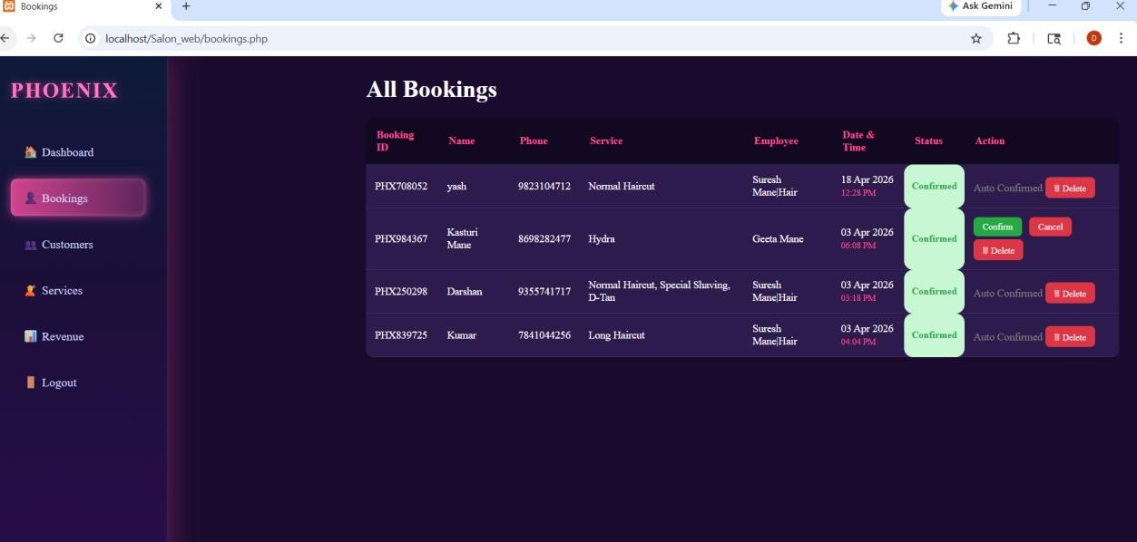

Customers :

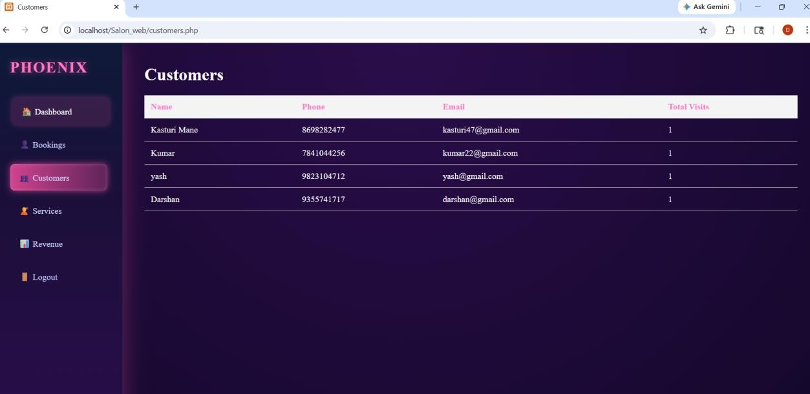

Services :
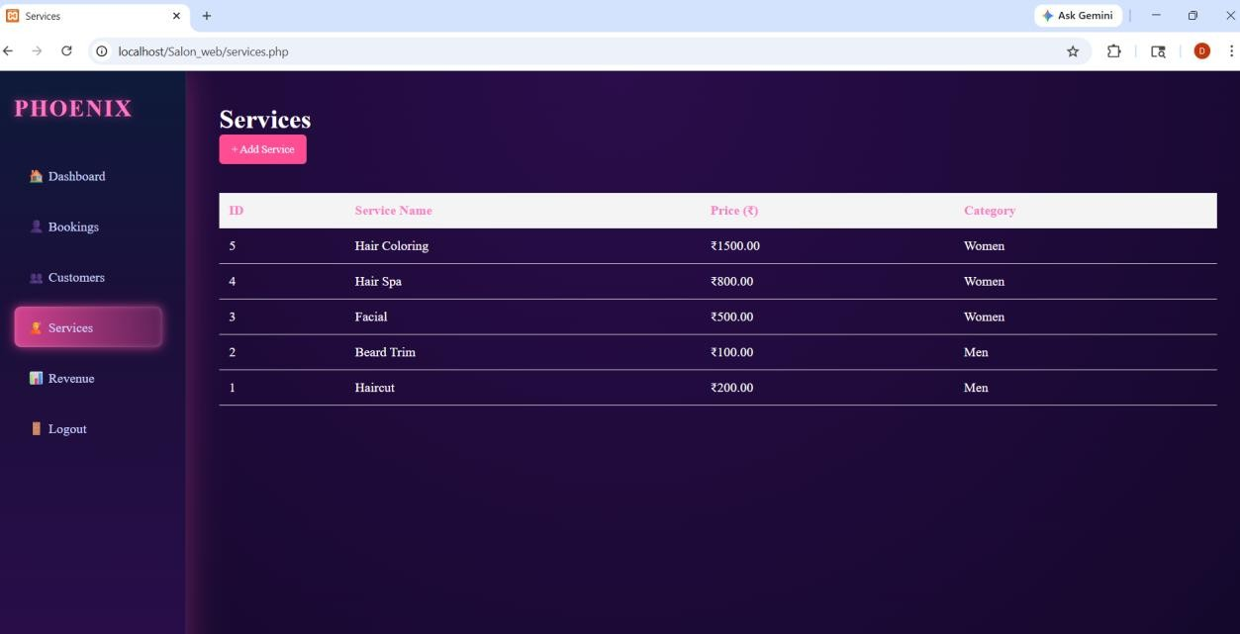

Revenue
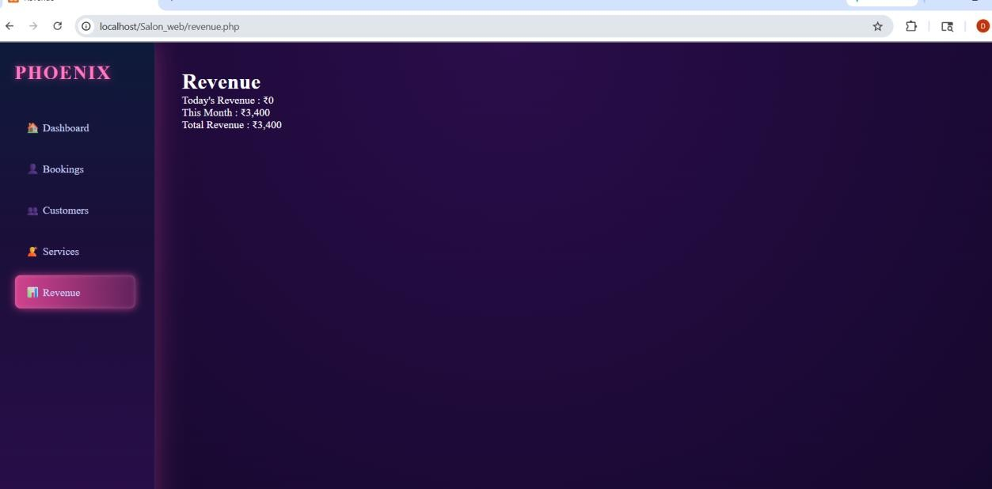

CONCLUSION AND SUGGESTIONS

Conclusion
The Salon Management System was successfully developed to automate and simplify the daily operations of a salon. This system provides an efficient and reliable solution for managing customer records, scheduling appointments, and maintaining service details in a structured digital environment. By replacing manual record-keeping methods with an automated system, the application reduces errors, saves time, and improves overall productivity.
The project was designed based on the real requirements observed in our own salon, making it a practical solution to real-world problems.
The system ensures secure data storage, easy access to information, and better organization of salon activities. It also enhances customer satisfaction by providing faster and more accurate service management.
Overall, the Salon Management System demonstrates how modern web technologies can be used to improve business operations, reduce manual workload, and support better decision- making. The successful implementation of this system shows its potential to be used effectively in small and medium-sized salon businesses

Suggestions
The Salon Management System has been successfully developed to manage salon operations efficiently. However, there are several improvements that can be implemented in the future to enhance the performance, usability, and functionality of the system. These suggestions aim to make the system more user-friendly, secure, and suitable for growing business needs.
With continuous technological advancements, integrating additional features can help improve customer experience and streamline salon management further. Regular system updates and maintenance are also recommended to ensure smooth operation and data security.

Suggestions for Improvement
- Implement an online booking system for customers
- Add SMS or email notifications for appointment reminders
- Integrate online payment options for billing and transactions
- Develop a mobile application version of the system
- Add backup and recovery features to protect data
- Improve the user interface design for better usability
- Implement role-based access control for multiple staff members
- Add report generation and analytics for business insights
- Enhance security features to prevent unauthorized access

Future Enhancements

- Online Appointment Booking: Allow customers to book appointments directly through the website.
- SMS and Email Notifications: Send automatic reminders for appointments and service updates.
- Online Payment Integration: Enable secure digital payments using credit/debit cards or UPI.
- Mobile Application Development: Create a mobile app version of the system for easy access on smartphones.
- Customer Feedback System: Allow customers to provide ratings and reviews for services.
- Advanced Reporting and Analytics: Generate detailed reports on revenue, customer trends, and service performance.
- Multi-User Access: Support multiple staff accounts with different roles and permissions.
- Cloud-Based Data Storage: Store data on cloud servers for better accessibility and backup.
- Inventory Management: Track salon products and supplies automatically.

REFRENCES

References

- Websites
- W3Schools – https://www.w3schools.com
(Used for learning HTML, CSS, JavaScript, PHP, and MySQL concepts)

- MDN Web Docs – https://developer.mozilla.org
(Used for JavaScript and web development documentation)

- Stack Overflow – https://stackoverflow.com
(Used for troubleshooting coding errors and solutions)

- PHP Official Documentation – https://www.php.net
(Used for understanding PHP functions and syntax)

- MySQL Official Documentation – https://dev.mysql.com
(Used for database design and SQL queries)

- Software Tools
- XAMPP – Local server environment for running PHP and MySQL
- Visual Studio Code – Code editor used for development 10 . phpMyAdmin – Database management tool
Google Chrome – Web browser used for testing the application
12. GitHub – Version control and project hosting platform.

